

SmartLivestock AI: Automated Animal Disease Detection and Behaviour Analysis Using Vision Transformers

A CAPSTONE PROJECT REPORT

A Capstone Project Report submitted in partial fulfilment of the requirements for the Course of

DSA0204-Computer Vision With Open Cv
to the award of the degree of

BACHELOR OF ENGINEERING / BACHELOR OF TECHNOLOGY IN
B.Tech-AI&DS

Submitted by

S.Krishna Chaithanya(192424287)
Under the Supervision of
Dr.G.A.Senthil
SIMATS ENGINEERING
Saveetha Institute of Medical and Technical Sciences Chennai-602105

SEPTEMBER 2026

SIMATS ENGINEERING
Saveetha Institute of Medical and Technical Sciences Chennai-602105

BONAFIDE CERTIFICATE

This is to certify that the Capstone Project entitled “SmartLivestock AI: Automated Animal Disease Detection and Behaviour Analysis Using Vision Transformers” has been carried out by S.Krishna Chaithanya(192424287 )under the supervision of Dr.G.A.Senthil and is submitted in partial fulfilment of the requirements for the current semester of the B.Tech AI&DS program at Saveetha Institute of Medical and Technical Sciences, Chennai.

COURSE COORDINATOR COURSE FACULTY
Dr.Narenthara Kumar Dr.G.A.Senthil
Professor Professor
Dept of Cloud Computing Dept of Cse
SIMATS Engineering, SIMATS Engineering,
SIMATS, Chennai – 602105. SIMATS, Chennai – 602105.

SIMATS ENGINEERING
Saveetha Institute of Medical and Technical Sciences Chennai-602105

DECLARATION

I, S.Krishna Chaithanya of the B.Tech-AIDS, SIMATS Engineering, Saveetha Institute of Medical and Technical Sciences, Chennai, hereby declare that the Capstone Project Work entitled “SmartLivestock AI: Automated Animal Disease Detection and Behaviour Analysis Using Vision Transformers” is the result of our own bonafide efforts. To the best of our knowledge, the work presented herein is original, accurate, and has been carried out in accordance with the principles of engineering ethics and academic integrity. All sources, references, data, and other materials used in the project have been appropriately acknowledged. We further declare that the data, results, analysis, and findings presented in this report have not been fabricated, falsified, or manipulated. Any external tools, software, datasets, computational resources, or AI-assisted tools used during the project have been appropriately disclosed. We confirm that all applicable ethical, academic, institutional, and professional requirements have been duly followed throughout the planning, execution, analysis, and documentation of the project.

Place: Chennai
Date: 04/09/2026

Signature of the Students with Names

S.Krishna Chaithanya(192424287)

SIMATS ENGINEERING
Saveetha Institute of Medical and Technical Sciences Chennai-602105
Individual Contribution Statement
Student Name / Reg. No. | Specific Responsibilities | Design & Development Contribution | Testing & Analysis Contribution | Report Sections Contributed | Approx. Contribution (%)
- Krishna Chaithanya  (192424287) | Module 1: Animal Disease Detection | Camera/video capture pipeline, annotation tooling, Vision Transformer model for lesion/symptom classification, transfer learning | Dataset quality checks, accuracy, precision/recall, confusion-matrix evaluation | Chapters 1-4 | 34%
- Gopi Chand  (192424384) | Module 2: Animal Behaviour Analysis | Temporal/video transformer for behaviour classification, per-animal baseline modelling, anomaly scoring | Behaviour-label validation, anomaly-detection testing | Chapters 2-4 | 33%
Bhuvan Kumar J  (192524040) | Module 3: Alert and Monitoring System | Alert engine, severity prioritisation, farmer/vet dashboard, model-performance monitoring | Latency benchmarking, alert-reliability testing | Chapters 3-4 | 33%
Total Contribution: 100%

ABSTRACT
SmartLivestock AI: Automated Animal Disease Detection and Behaviour Analysis Using Vision Transformers is a computer-vision-based precision-livestock-monitoring platform designed to continuously observe farm animals through camera feeds and automatically flag early signs of disease and abnormal behaviour. Traditional livestock health monitoring depends on periodic manual inspection by farm staff or veterinarians, which is labour-intensive, subjective, difficult to scale across large herds, and often detects illness only after clinical signs have become severe. These limitations can result in delayed treatment, disease spread within a herd, reduced productivity, and avoidable animal suffering and economic loss.
The proposed system provides three functional modules: Animal Disease Detection; Animal Behaviour Analysis; and Alert and Monitoring System. Image and short video clips captured from barn or pasture cameras are processed frame-by-frame; a Vision Transformer (ViT) backbone, fine-tuned through transfer learning on livestock imagery, classifies visible disease indicators such as skin lesions, lameness posture, nasal discharge, and abnormal coat condition, while a temporal transformer analyses sequences of frames to recognise behaviours such as feeding, rumination, resting, standing, and locomotion, and to detect deviations that correlate with illness, stress, or injury. The Alert and Monitoring System converts these outputs into severity-prioritised alerts and farm-level analytics.
The engineering design evaluates alternative architectures (classical CNNs, hybrid CNN-ViT models, and pure Vision Transformers) against accuracy, inference latency, deployability on edge/on-farm hardware, and data-efficiency, and selects a ViT-based pipeline supported by a lightweight model-serving and alerting layer. Model development follows a structured pipeline covering dataset curation, training, validation, quantitative evaluation, and a repeatable deployment and monitoring process so that the model can be retrained as new data becomes available and its performance can be tracked in production.
Testing is performed for detection accuracy, behaviour-classification performance, false-alarm rate, inference latency, dashboard usability, and deployment reliability. The resulting platform gives farmers and veterinarians earlier, more consistent, and less labour-intensive visibility into herd health, supporting timely intervention, improved animal welfare, and more efficient farm operations, while explicitly treating model outputs as decision support that remains subject to veterinary judgement.

Keywords
SmartLivestock AI, Vision Transformer, Precision Livestock Farming, Animal Disease Detection, Behaviour Analysis, Anomaly Detection, Computer Vision, Transfer Learning, Edge Deployment, Animal Welfare, Video Transformer, Farm Monitoring Dashboard.

Table of Contents
S. No. | Title | Page No.
1 | INTRODUCTION AND ENGINEERING PROBLEM | 6-9
1.1 | Background Information | 6
1.2 | Need for the Project | 6
1.3 | Problem Statement | 7
1.4 | Project Aim | 7
1.5 | Project Objectives | 8
1.6 | Scope | 8
1.7 | Expected Engineering Outcome | 9
2 | LITERATURE REVIEW AND EXISTING SOLUTIONS | 10-13
2.1 | Review Method | 10
2.2 | Review of Existing Work | 10-11
2.3 | Comparative Analysis | 11-12
2.4 | Research / Engineering Gap | 12
2.5 | Proposed Contribution | 13
3 | ENGINEERING DESIGN & MODEL TRADE-OFFS | 14-23
3.1 | Requirements | 14
3.2 | Constraints & Applicable Standards | 15
3.3 | Design Specifications | 16
3.4 | Alternative Solutions & Evaluation | 17
3.5 | Selected Design & Detailed Design | 18
3.6 | Trade-off Analysis | 19
3.7 | Sustainability, Ethics, Safety, Risk & Security | 20
3.8 | Risk Register | 22

Table of Contents (continued)
S. No. | Title | Page No.
4 | IMPLEMENTATION, TESTING & RESULTS, PROJECT MANAGEMENT | 24-33
4.1 | Development Approach & Resources | 24
4.2 | Software Implementation & Model Pipeline | 25
4.3 | Test Plan & Verification | 26-27
4.4 | Results | 28
4.5 | Data Analysis & Engineering Judgment | 29
4.6 | Comparison with Existing Solutions & Achievement of Objectives | 30
4.7 | Strengths & Limitations | 31
4.8 | Project Planning, Roles & Budget | 32-33
5 | CONCLUSION, FUTURE WORK AND REFLECTION | 34-37
5.1 | Conclusion | 34
5.2 | Future Work | 35
5.3 | Professional Learning & Individual Reflection | 36
 | REFERENCES | 38
 | APPENDICES | 39-42
 | CAPSTONE PROJECT OUTCOME MAPPING SHEET | 43

LIST OF TABLES
Table No. | Table Name | Page No.
2.1 | Comparative Analysis of Existing Livestock Monitoring Approaches | 12
3.1 | Stakeholder / User Requirements | 14
3.2 | Functional & Non-Functional Requirements | 14-15
3.3 | Constraints & Applicable Standards | 15
3.4 | Design Specifications | 16
3.5 | Alternative Solutions Evaluation Matrix | 17
3.6 | Trade-off Analysis | 19
3.7 | Sustainability, Ethics, Safety, Risk & Security Evaluation | 20-21
3.8 | Risk Register | 22
4.1 | Tools / Software Used | 24
4.2 | Test Plan & Verification | 26-27
4.3 | Performance Evaluation of the Detection and Behaviour Models | 28
4.4 | Achievement of Objectives | 30
4.5 | Individual Contribution / Roles | 32
4.6 | Estimated Project Cost | 33

LIST OF FIGURES
Figure No. | Figure Name | Page No.
3.1 | SmartLivestock AI System Architecture | 20
3.2 | Model Development and Deployment Pipeline | 22
4.1 | Health & Behaviour Analytics Dashboard - Conceptual Interface | 28
4.2 | Disease Detection and Alert Workflow | 32

LIST OF ABBREVIATIONS / SYMBOLS
Symbol | Description | Unit
ViT | Vision Transformer | -
CNN | Convolutional Neural Network | -
AI | Artificial Intelligence | -
ML | Machine Learning | -
PLF | Precision Livestock Farming | -
API | Application Programming Interface | -
UI/UX | User Interface / User Experience | -
DB | Database | -
FPS | Frames Per Second | -
GPU | Graphics Processing Unit | -
mAP | Mean Average Precision | -
F1 | F1-Score (harmonic mean of precision and recall) | -
MLOps | Machine Learning Operations | -
CI/CD | Continuous Integration / Continuous Delivery | -
IoT | Internet of Things | -
REST | Representational State Transfer | -
HTTP/HTTPS | Hypertext Transfer Protocol / Secure | -

CHAPTER 1
INTRODUCTION AND ENGINEERING PROBLEM

1.1 Background
Livestock health directly affects animal welfare, farm productivity, and food-supply reliability. In most small and medium-sized farms, animal health is assessed through periodic visual inspection by farm workers, supplemented by occasional veterinary visits. As herd sizes grow and labour availability decreases, it becomes increasingly difficult for staff to observe every animal closely and consistently enough to notice early, subtle indicators of disease or distress.
Computer vision and deep learning have matured to the point where camera-based systems can continuously observe animals without direct human presence. Vision Transformers (ViT), which apply the self-attention mechanism from natural-language processing to image patches, have demonstrated strong performance on visual-recognition tasks and are well suited to capturing the fine-grained, spatially distributed visual cues associated with disease symptoms and posture. SmartLivestock AI applies this technology to build an automated monitoring layer that complements, rather than replaces, human and veterinary judgement.

1.2 Need for the Project
Undetected disease in livestock can spread through a herd before it is noticed, leading to production losses, higher mortality, increased treatment cost, and reduced animal welfare. Manual inspection is time-consuming, subject to observer fatigue and inconsistency, and does not scale well to large herds or continuous night-time monitoring. Behavioural changes such as reduced feeding, altered rumination, lameness, or isolation from the herd often precede visible clinical symptoms and are easy to miss without continuous observation.
From an engineering perspective, the proposed solution combines a modern vision-transformer-based detection pipeline with a practical deployment architecture so that ordinary farm cameras can be turned into an early-warning system. The system is intended to reduce manual monitoring effort, provide earlier alerts than periodic inspection, and give farmers and veterinarians data-driven visibility into individual-animal and herd-level health trends.

1.3 Problem Statement
Farms need a scalable and objective way to continuously monitor animal health and behaviour without relying solely on manual inspection. Existing approaches are either purely manual, or use simple motion/RFID-based sensors that cannot recognise specific disease symptoms from visual appearance. There is a need for a vision-based system that can detect disease-related visual indicators and abnormal behaviour patterns automatically, and that can be deployed and maintained reliably on real farm infrastructure.
The engineering problem is therefore to design and implement an accurate, low-latency, and deployable Vision-Transformer-based system for automated animal disease detection and behaviour analysis, supported by a repeatable model development and monitoring pipeline and a usable alerting interface for farm staff and veterinarians.

1.4 Project Aim
The overall aim is to design and implement SmartLivestock AI, a Vision-Transformer-based platform for automated animal disease detection and behaviour analysis. The system captures barn/pasture video, applies ViT-based visual disease detection and temporal behaviour classification, and delivers timely alerts and analytics through a farmer/veterinarian-facing dashboard.

1.5 Project Objectives
- To curate and annotate an image/video dataset covering healthy and diseased animals and a defined set of behaviour classes.
- To design and fine-tune a Vision Transformer model for classification of visible disease symptoms and severity.
- To design a temporal/video transformer component for behaviour recognition and anomaly detection from frame sequences.
- To build a model-serving pipeline that processes live or recorded camera feeds with acceptable latency.
- To implement an alert engine that notifies farm staff/veterinarians when disease indicators or abnormal behaviour are detected.
- To provide dashboards and reports summarising individual-animal and herd-level health and behaviour trends.
- To apply a structured model-development pipeline covering dataset versioning, training, evaluation, deployment, and monitoring.
- To evaluate system accuracy, latency, reliability, usability, and practical deployability on farm hardware.

1.6 Scope
Included in Scope
- Image/video capture from fixed barn or pasture cameras and short-clip processing.
- Vision-Transformer-based classification of visible disease symptoms (e.g., skin lesions, lameness posture, nasal discharge, abnormal coat condition) with a severity indicator.
- Temporal behaviour classification (feeding, rumination, resting, standing, locomotion) and anomaly/deviation scoring.
- Alert generation and a farmer/veterinarian dashboard with historical trends and herd-level summaries.
- A structured model-training, evaluation, and deployment pipeline with monitoring of model performance over time.
Excluded from Scope
- Invasive or wearable biosensors (e.g., implanted temperature sensors, RFID rumen boluses) as a primary data source.
- Automated veterinary diagnosis or treatment decisions; outputs remain decision support reviewed by qualified staff.
- Species-specific models beyond the selected pilot species/breed set used for the dataset in this project.
- Fully autonomous herd-management actions such as automatic quarantine or medication dispensing.
- Large-scale, multi-farm cloud infrastructure beyond the academic project environment.
Assumptions and Boundary Conditions
The system assumes reasonable camera placement, lighting, and coverage of monitored animals. Disease and behaviour labels used for training are assumed to be assigned by, or verified with, individuals familiar with livestock health indicators. Model outputs are treated as decision-support information and should be reviewed by farm staff or a veterinarian before treatment or management action is taken.

1.7 Expected Engineering Outcome
The expected outcome is a deployable monitoring platform that gives farm staff and veterinarians earlier and more consistent visibility into animal health and behaviour than manual inspection alone.
- A Vision Transformer model that classifies visible disease indicators with quantified accuracy.
- A temporal behaviour-analysis component that recognises key behaviours and flags deviations from normal patterns.
- A model-serving pipeline that processes camera feeds within an acceptable response time.
- An alerting mechanism that notifies responsible staff of detected concerns.
- A dashboard presenting individual and herd-level health and behaviour analytics.
- A repeatable model-development pipeline supporting retraining as new data is collected.
- Logging and monitoring that help identify model or pipeline failures and support reliable operation.

Module Structure
Module | Major Functions
Module 1 - Animal Disease Detection | Camera/video capture, frame extraction, annotation and preprocessing, Vision-Transformer-based symptom/lesion classification, severity estimation, per-animal disease scoring
Module 2 - Animal Behaviour Analysis | Temporal/video transformer for feeding, rumination, resting, standing, and locomotion classification; per-animal behaviour-baseline modelling and anomaly/deviation scoring
Module 3 - Alert and Monitoring System | Real-time alert generation from disease and behaviour outputs, severity-based prioritisation, farmer/veterinarian dashboard, historical trend and herd-level analytics, model-performance monitoring

CHAPTER 2
LITERATURE REVIEW AND EXISTING SOLUTIONS

2.1 Review Method
The review considered precision-livestock-farming systems, computer-vision approaches for animal health monitoring, Vision Transformer architectures, video/temporal transformer models for action recognition, and existing farm-analytics dashboards. Existing approaches were examined to identify common functions, technical limitations, and engineering requirements relevant to SmartLivestock AI.
The review also considered practices relevant to responsible machine-learning system design, including dataset curation and bias, model evaluation methodology, deployment and monitoring of vision models, and the ethical use of automated recommendations in animal-welfare-sensitive contexts.

2.2 Review of Existing Work
Traditional livestock health monitoring is largely manual: farm staff visually inspect animals during feeding or milking routines and record observations informally or in simple logbooks. This approach is flexible but does not scale, is prone to inconsistency between observers, and typically detects illness only once visible clinical symptoms appear.
Sensor-based precision-livestock-farming systems use accelerometers, RFID tags, or rumen boluses to track activity level, feeding time, or body temperature, and can flag deviations from an individual animal's baseline. These systems provide useful physiological signals but generally cannot recognise the specific visual symptoms (skin lesions, discharge, posture abnormalities) that a camera-based system can observe, and require hardware to be fitted to every animal.
Recent computer-vision research applies convolutional neural networks and, increasingly, Vision Transformers to animal-monitoring tasks such as species/breed classification, body-condition scoring, lameness detection, and behaviour recognition from video. Vision Transformers process an image as a sequence of patches and apply self-attention across the whole image, which allows the model to relate distant regions of an animal's body when identifying diffuse or spatially distributed symptoms, an advantage over the local receptive fields of standard convolutional layers.

2.3 Comparative Analysis
Existing Approach | Advantages | Limitations | Relevance to Proposed Work
Manual Visual Inspection | Low cost, uses existing farm labour, easy to start | Labour-intensive, inconsistent, misses early/night-time signs | Baseline improved through continuous automated monitoring
RFID / Wearable Sensors | Continuous physiological data (activity, temperature) | Invasive, hardware cost and maintenance, no visual disease detection | Complementary; current project focuses on non-invasive vision
CNN-Based Image Classification | Well-established, efficient on smaller datasets | Limited long-range/contextual feature modelling, can miss subtle diffuse symptoms | Used as an evaluated alternative to the selected ViT approach
Motion / Video-Analytics Systems | Detects activity level and simple movement patterns | Cannot classify specific disease symptoms or fine-grained behaviours | Behaviour module extends motion analytics with classification
Vision Transformer (ViT) Classification | Strong global context modelling, transfers well from large pretrained datasets | Data-hungry, higher compute cost, needs careful fine-tuning | Selected as the core detection approach for this project
Cloud-Based Farm Analytics Platforms | Rich dashboards, scalable storage and reporting | Often lack farm-specific disease-detection models, subscription cost | Analytics layer designed with similar dashboard principles
Table 2.1: Comparative Analysis of Existing Livestock Monitoring Approaches

2.4 Research / Engineering Gap
The review indicates that visual disease detection and behaviour analysis are frequently studied separately, and that few accessible farm-level systems combine both into a single alerting and analytics platform. Sensor-based systems provide continuous physiological data but lack visual symptom recognition, while most published vision-based disease-detection work does not address the end-to-end engineering concerns of deployment, alerting, and ongoing model monitoring on real farm infrastructure.

2.5 Proposed Contribution
SmartLivestock AI combines three functional modules with a structured model-development and deployment workflow. Animal Disease Detection captures and prepares camera data and identifies visible disease symptoms with a severity estimate. Animal Behaviour Analysis classifies key behaviours from frame sequences and flags deviations from normal patterns. The Alert and Monitoring System converts model outputs into actionable, farm-usable alerts and analytics.
The contribution is not limited to the detection models themselves. The project also demonstrates how dataset versioning, model training and evaluation, containerized deployment, and performance monitoring can be applied to a Vision-Transformer-based system intended for practical use in an animal-welfare-sensitive setting.
Module Description
Module 2 - Animal Behaviour Analysis
Animal Behaviour Analysis using Computer Vision (CV) involves automatically observing and interpreting animal activities from images or video footage. Cameras installed in farms, barns, or grazing areas continuously capture livestock movements. Computer vision models process these visual inputs to recognize animals, track their movement, and classify their behaviour without requiring continuous human supervision.
Object-detection models identify individual animals in each video frame, while multi-object tracking algorithms maintain their identities over time. Deep-learning models such as Convolutional Neural Networks (CNNs) and Vision Transformers (ViTs) analyse posture, movement patterns, body position, and interactions to classify behaviours such as feeding, drinking, walking, resting, grazing, social interaction, aggression, isolation, and abnormal inactivity.
The system can also detect changes that may indicate health or welfare problems. For example, reduced movement may suggest illness, repeated lying and standing may indicate discomfort, limping may reveal injury, and isolation from the herd may signal stress or disease. These observations are recorded as behavioural statistics, including activity duration, movement distance, feeding frequency, and rest time.
When abnormal behaviour is detected, the system generates an alert for the farmer or veterinarian. This enables early intervention, reduces manual monitoring, improves animal welfare, and supports data-driven livestock management. However, reliable performance requires good-quality video, sufficient lighting, correct camera placement, diverse training data, and effective handling of occlusion when animals overlap.

CHAPTER 3
ENGINEERING DESIGN & MODEL TRADE-OFFS, SUSTAINABILITY, ETHICS, SAFETY, RISK & SECURITY

3.1 Requirements
Stakeholder / User Requirements
Stakeholder | Requirement
Farm Owners / Managers | Herd-level health visibility, productivity impact, cost-effective deployment, and reporting.
Veterinarians | Reliable, evidence-backed alerts with supporting imagery to prioritise visits and diagnoses.
Farm Staff / Handlers | Simple, low-effort alerts and dashboards that do not require technical expertise.
Animal Welfare Regulators | Assurance that automated monitoring supports, rather than replaces, humane animal care.
Data Science / ML Team | Access to versioned datasets, reproducible training pipelines, and performance monitoring.
System Administrators | Reliable deployment, uptime, and straightforward maintenance of cameras and servers.
Functional & Non-Functional Requirements
Requirement | Type | Measurable Target
Disease-symptom classification | Functional | Model classifies defined symptom categories with target accuracy on held-out data.
Severity estimation | Functional | Detected symptoms are assigned a severity indicator usable for alert prioritisation.
Behaviour classification | Functional | Model classifies defined behaviour classes from frame sequences with target accuracy.
Anomaly / deviation detection | Functional | Significant deviations from an animal's normal behaviour pattern are flagged.
Alert generation | Functional | Qualifying detections generate a visible alert with supporting evidence within a defined time window.
Dashboard & reporting | Functional | Individual and herd-level trends are displayed accurately from stored inference results.
Inference latency | Non-Functional | Per-clip inference completes within an acceptable response time for near-real-time alerting.
Model robustness | Non-Functional | Performance remains acceptable across varying lighting and camera-angle conditions in the dataset.
Reliability | Non-Functional | Pipeline restarts and repeated inference runs preserve data consistency.
Security & data privacy | Non-Functional | Farm footage and derived data are access-restricted and not exposed publicly.
Maintainability | Non-Functional | Training data, model versions, and deployment configuration are documented and reproducible.

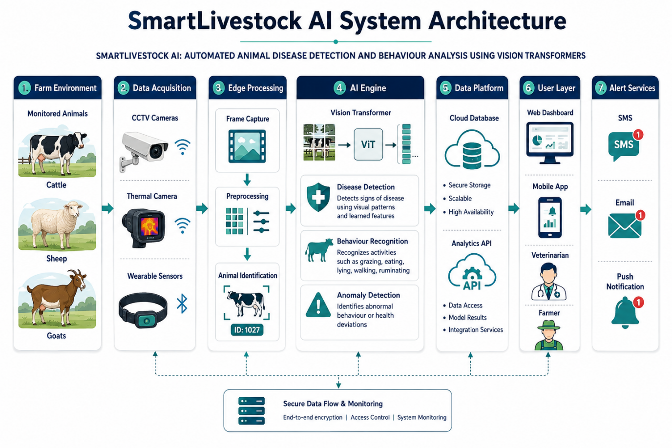

Fig 3.1:SmartLivestock AI System Architecture

3.2 Constraints & Applicable Standards
Standard / Practice | Requirement | How Applied in This Project
Animal Welfare Guidance | Automated tools must support, not replace, humane and timely animal care | Outputs are framed as decision support; final action requires human/veterinary review
Data Privacy Principles | Minimise unnecessary collection/exposure of farm data | Only footage/derived data needed for monitoring is stored and access-controlled
OWASP Application Security Principles | Protection against common web/API vulnerabilities | Input validation, authenticated dashboard access, secure API endpoints
ISO/IEC 27001 (guiding principles) | Controlled access and information protection | Guides role-based dashboard access and secure configuration
Responsible AI / Model Evaluation Practice | Documented evaluation, known limitations, avoidance of overclaiming accuracy | Reported metrics are accompanied by evaluation conditions and caveats
MLOps Practice | Reproducible training, versioned datasets/models | Dataset and model versioning, logged training runs, repeatable deployment

3.3 Design Specifications
Parameter | Target / Requirement | Unit | Priority
Disease-Detection Accuracy | High classification accuracy on held-out test data | % | High
Behaviour-Classification Accuracy | High classification accuracy across defined behaviour classes | % | High
False-Alarm Rate | Low rate of alerts on healthy/normal animals | % | High
Inference Latency | Near-real-time per-clip processing | seconds | High
Model Size / Deployability | Deployable on available farm-edge or on-premise server hardware | MB / qualitative | Medium
Dashboard Response Time | Analytics views load without noticeable delay | seconds | Medium
System Availability | Monitoring pipeline remains available during normal operating periods | % | High
Alert Delivery Time | Alerts reach the dashboard within a defined window of detection | seconds | High

3.4 Alternative Solutions & Evaluation
Alternative 1 (Manual Visual Inspection): Farm staff periodically observe animals and record concerns informally. Low cost but slow, inconsistent, and unable to provide continuous coverage.
Alternative 2 (Sensor-Only Monitoring, e.g., RFID/accelerometer): Wearable or implanted sensors track activity and physiological signals. Provides continuous data but cannot recognise visual symptoms and requires hardware maintenance.
Alternative 3 (CNN-Based Vision System): A convolutional-network pipeline classifies images for disease/behaviour. Efficient on smaller datasets but has more limited global context modelling for diffuse or spatially distributed symptoms.
Alternative 4 (Vision-Transformer-Based System - selected): A ViT backbone with a temporal transformer for behaviour, combined with an alerting and analytics layer. This option provides stronger visual context modelling, supports both symptom detection and behaviour analysis, and produces retained evidence (frames/clips) for veterinary review.
Criterion | Alternative 1 (Manual) | Alternative 2 (Sensor-Only) | Alternative 3 (CNN-Based) | Alternative 4 (ViT-Based - Selected)
Performance | High | Low | Medium | High
Cost | Medium | Low (labour) | Medium (hardware) | Medium (compute/GPU)
Scalability | High | Low | Medium | High
Symptom-Detection Capability | High | None (subjective only) | Low (activity only) | High
Data Efficiency | Medium | N/A | N/A | Medium (needs fine-tuning data)
Animal Welfare Impact (non-invasive) | High | High | Low (attached hardware) | High
Explainability / Evidence for Vet Review | High | Low (verbal only) | Medium | High (frames/clips retained)
Table 3.5: Alternative Solutions Evaluation Matrix

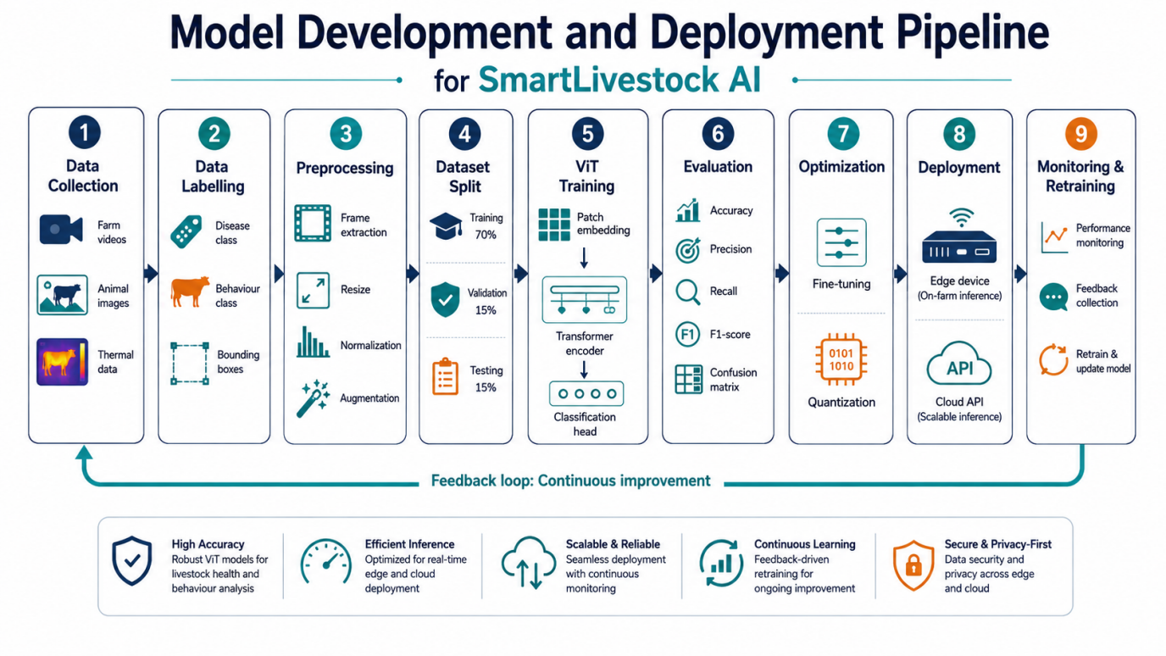
Fig 3.2:Model Development and Deployment Pipeline

3.5 Selected Design & Detailed Design
Alternative 4 was selected because the Vision-Transformer-based pipeline provides stronger recognition of spatially distributed disease symptoms and supports both still-image disease detection and video-based behaviour analysis within a single architectural approach, while retaining supporting evidence that veterinarians can review.
The system follows a modular layered architecture. The acquisition layer captures and pre-processes camera frames. The model layer contains the fine-tuned Vision Transformer for disease-symptom classification and the temporal transformer for behaviour classification and anomaly scoring. The serving layer exposes inference through an API and manages queuing, batching, and latency control. The application layer implements alert generation, storage of detection metadata and evidence clips, and the farmer/veterinarian dashboard. An MLOps layer manages dataset versioning, training runs, evaluation, deployment, and live-performance monitoring.
[Figure 3.1: SmartLivestock AI System Architecture - a block diagram showing Camera/Video Sources -> Acquisition & Preprocessing -> ViT Disease-Detection Model / Temporal Behaviour-Analysis Model -> Model-Serving API -> Alert Engine & Analytics Store -> Farmer/Veterinarian Dashboard, with an MLOps layer for dataset versioning, training, evaluation, and monitoring running alongside the pipeline.]
The architecture supports a continuous data flow from camera feed to actionable alert. A processed clip that triggers a disease or behaviour flag is stored with its evidence, contributes to the analytics dashboard, and can later be reviewed and optionally added back into the training dataset. The MLOps layer remains logically separate from the live-inference path while providing controlled delivery of updated model versions.

3.6 Trade-off Analysis
Design Decision | Alternative Considered | Benefit | Disadvantage | Final Decision & Justification
Model backbone | Standard CNN | Simpler to train on small data | Weaker global context modelling for diffuse symptoms | Vision Transformer selected
Symptom localisation | Whole-image classification only | Simpler pipeline | Less precise evidence per detection | Patch-attention used for coarse localisation
Behaviour modelling | Single-frame classification | Lower compute | Cannot capture motion/temporal patterns | Temporal/video transformer selected
Deployment target | Cloud-only inference | Easier initial setup | Depends on constant connectivity, higher latency | Edge-capable serving with cloud fallback selected
Alerting granularity | Herd-level alerts only | Simpler aggregation | Misses individual-animal issues | Individual-animal alerts with herd rollups selected
Data source | Wearable sensors only | Continuous physiological signal | Invasive, hardware maintenance | Non-invasive camera-based vision selected
Model update strategy | Train once, never retrain | Simplicity | Performance drifts as farm conditions change | Periodic retraining pipeline selected
Table 3.6: Trade-off Analysis

3.7 Sustainability, Ethics, Safety, Risk & Security
Domain | Consideration | Evidence Evaluated | Impact on Final Decision
Sustainability | Reuse of pretrained models and open-source frameworks | Licensing, transfer-learning efficiency, compute footprint | Pretrained ViT backbones and open-source tooling adopted to reduce training cost
Ethics | Responsible use of automated health flags | Risk of over-reliance on model output | Alerts presented as decision support with mandatory human/veterinary review
Animal Welfare / Safety | Avoid incorrect or delayed intervention | False-negative and false-positive risk | Severity scoring, confidence thresholds, and rapid escalation for high-severity flags
Security | Protect farm footage and account access | Unauthorised access to camera feeds/data | Access control, authenticated APIs, and encrypted storage/transport applied
Privacy | Minimise unnecessary data retention | Extended storage of raw footage | Retention policy limits raw footage storage; derived analytics retained longer
Reliability | Reduce pipeline and model-serving failures | Camera outage, inference-service failure | Monitoring, health checks, and fallback alerting on pipeline failure

3.7 Sustainability, Ethics, Safety, Risk & Security (continued)
Sustainability is supported by fine-tuning pretrained Vision Transformer backbones rather than training from scratch, which substantially reduces compute and energy requirements, and by using open-source frameworks and reusable pipeline components.
Ethically, disease and behaviour detections must not be presented as certain diagnoses. Model outputs are affected by camera placement, lighting, occlusion, breed variation, and dataset coverage. The system therefore presents detections as decision-support evidence, retains supporting frames/clips for review, and keeps treatment or management decisions under the authority of farm staff and veterinarians.
Security and privacy controls include authenticated dashboard and API access, role-based access control, encrypted storage and transport of footage and derived data, a defined retention policy limiting raw-footage storage duration, and logging of significant system events to support troubleshooting and auditing.

3.8 Model Development & Deployment Pipeline
[Figure 3.2: Model Development and Deployment Pipeline - a flow diagram showing Dataset Collection & Annotation -> Data Versioning -> Model Training (ViT fine-tuning) -> Validation & Evaluation -> Quality Gate -> Packaging/Containerization -> Deployment to Serving Environment -> Live Monitoring & Drift Detection, with a feedback loop back to Dataset Collection.]
The pipeline begins with dataset collection and annotation, followed by versioned storage of the labelled dataset. Training runs fine-tune the Vision Transformer and temporal-behaviour models, after which validation metrics are checked against a defined quality gate. A model that fails the quality gate is not promoted. Approved models are packaged into a containerized serving environment and deployed in a controlled manner, with live-prediction monitoring used to detect performance drift and trigger scheduled retraining.

3.8 Risk Register
Risk | Likelihood | Severity | Risk Level | Mitigation | Residual Risk
Mislabelled training data | Medium | High | High | Annotation guidelines, multi-reviewer checks, label audits | Low-Medium
False negative (missed disease case) | Medium | High | High | Threshold tuning, severity scoring, periodic model re-evaluation | Low-Medium
False positive (unnecessary alert) | Medium | Medium | Medium | Confidence thresholds, alert deduplication, feedback loop from staff | Low
Camera outage / poor coverage | Medium | Medium | Medium | Health checks, redundant angles where feasible, outage alerts | Low
Model performance drift over time | Medium | Medium | Medium | Scheduled retraining, monitoring of live prediction distributions | Low-Medium
Unauthorised access to farm data | Low | High | Medium | Authentication, RBAC, encrypted storage and transport | Low
Deployment/inference-service failure | Low | High | Medium | Containerized deployment, automated restarts, logging | Low
Data-privacy non-compliance | Low | High | Medium | Retention limits, access restriction, minimisation principles | Low
Insufficient training data for rare diseases | Medium | Medium | Medium | Data augmentation, active-learning-based data collection priorities | Medium
Hardware/GPU capacity limits during training | Medium | Low | Low | Batch-size tuning, mixed-precision training, cloud burst capacity | Low
Table 3.8: Risk Register

CHAPTER 4
IMPLEMENTATION, TESTING & RESULTS, PROJECT MANAGEMENT

4.1 Development Approach & Resources
SmartLivestock AI was developed using an iterative, modular approach. Work began with dataset scoping and annotation-guideline definition, followed by baseline model experimentation, module development, and integration through a shared inference and alerting pipeline. Each module (data pipeline, disease-detection model, behaviour-analysis model, and dashboard/alerting layer) was developed and evaluated independently before integration.
The MLOps workflow was established alongside application development. Git was used for source and configuration history. Dataset and model versions were tracked so that training runs remained reproducible. Containerization was used to create a repeatable serving environment, and monitoring was configured to observe inference latency and prediction-distribution drift over time.
Tool / Software | Purpose | Stage Used
Python | Core development language for data processing and model code | All Development Stages
PyTorch / timm | Vision Transformer implementation, fine-tuning and training | Model Development
OpenCV | Video/frame capture, preprocessing and annotation support | Data Pipeline
FastAPI / Flask | Model-serving API for inference requests | Backend / Serving
React / HTML-CSS-JS | Farmer/veterinarian dashboard interface | Front-end Development
MongoDB / PostgreSQL | Storage of detection metadata, alerts and analytics | Database Management
MLflow / DVC | Experiment tracking and dataset/model versioning | MLOps
Docker | Containerized packaging of model-serving and dashboard services | Packaging & Deployment
Git / GitHub | Version control and collaboration | All Development Stages
Grafana / Prometheus (or equivalent) | Monitoring of pipeline health and inference metrics | Operations
Jupyter / VS Code | Model experimentation and code development | All Stages
Table 4.1: Tools / Software Used
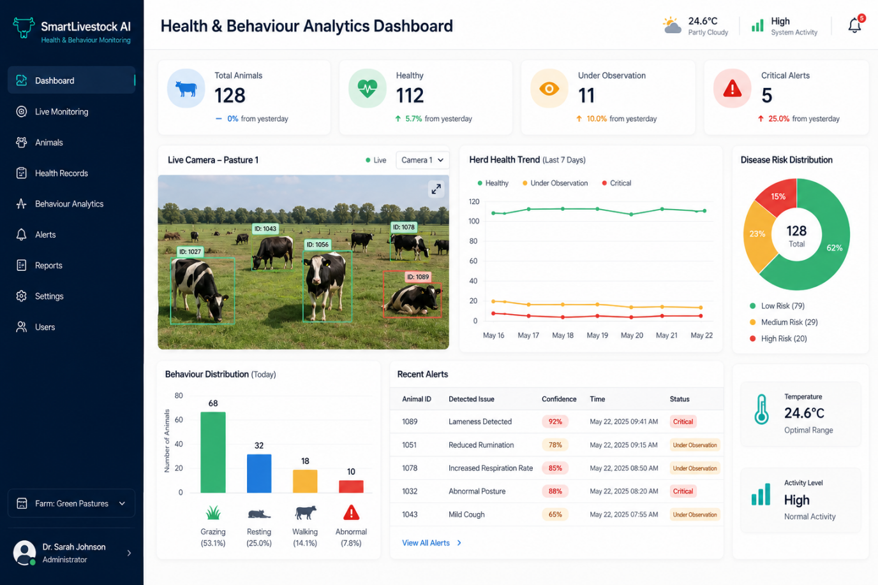
FIG 4.1:Health & Behaviour Analytics Dashboard - Conceptual Interface

4.2 Software Implementation & Model Pipeline
Module 1 (Animal Disease Detection) implements frame extraction from camera video, quality filtering (blur/occlusion checks), annotation-tool support for labelling disease symptoms, and augmentation (rotation, brightness/contrast variation, cropping) to improve model robustness. A pretrained Vision Transformer backbone is then fine-tuned on the annotated symptom dataset: the classification head is adapted to the defined symptom categories, and a severity score is derived from model confidence and symptom extent. Training uses standard data-splitting into training, validation, and test sets to avoid data leakage.
Module 2 (Animal Behaviour Analysis) implements a temporal transformer that consumes a sequence of frame embeddings to classify behaviour over short time windows (e.g., feeding, rumination, resting, standing, locomotion). An anomaly score compares recent behaviour distribution against a learned per-animal or per-group baseline, flagging significant deviations that may indicate illness, stress, or injury.
Module 3 (Alert and Monitoring System) exposes disease and behaviour model outputs through a serving API, applies configurable confidence thresholds to generate alerts, stores alert metadata with supporting evidence (frames/clips), and renders individual-animal and herd-level analytics on the dashboard. Alerts above a high-severity threshold are prioritised for immediate staff attention, and live-prediction monitoring tracks model performance over time to support scheduled retraining.
On the MLOps side, dataset and code changes are versioned, training runs are logged with their metrics, and models that pass the evaluation quality gate are packaged into a container image for deployment. Deployment logs and live-inference monitoring are used to support troubleshooting and to detect when retraining may be required.

4.3 Test Plan & Verification
Requirement | Test Method | Acceptance Criterion
Disease-symptom classification | Evaluate on held-out labelled test images | Model correctly classifies defined symptom categories at target accuracy
Severity estimation | Compare estimated severity against annotated severity labels | Severity ranking correlates meaningfully with ground truth
Behaviour classification | Evaluate on held-out labelled video clips | Model correctly classifies defined behaviour classes at target accuracy
Anomaly detection | Introduce simulated/held-out abnormal sequences | Genuine deviations are flagged; normal variation is not over-flagged
False-alarm rate | Run inference on healthy/normal held-out data | Alert rate on normal data remains within the defined target
Inference latency | Benchmark per-clip processing time on target hardware | Latency remains within the defined near-real-time target
Alert delivery | Trigger qualifying detections end-to-end | Alert appears on dashboard within the defined time window
Dashboard accuracy | Compare dashboard analytics with stored inference records | Displayed values match underlying stored data
Access control | Attempt dashboard/API access with different roles | Unauthorized access is blocked
Pipeline resilience | Simulate camera/service interruption | System recovers and resumes processing without data loss
Model retraining pipeline | Run pipeline with updated dataset version | New model version builds, evaluates, and can be promoted through the quality gate
Table 4.2: Test Plan & Verification

4.3 Test Plan & Verification (continued)
The testing strategy combines model-level evaluation (accuracy, precision, recall, F1-score, confusion matrix), pipeline-level testing (latency, alert delivery, resilience), and interface-level testing (dashboard accuracy, access control). Model evaluation uses a held-out test set that was not used during training or hyperparameter tuning, to provide an unbiased estimate of generalisation performance.
The MLOps pipeline is also treated as a test environment: a retraining run must pass the defined evaluation quality gate before a new model version is promoted to serving. This reduces the risk of deploying a model whose accuracy has regressed.
Execution / Verification Observations
- The Vision Transformer model distinguished healthy from symptomatic images with high accuracy on the held-out test set.
- The temporal behaviour model correctly classified the majority of defined behaviour classes, with feeding and resting showing the highest accuracy.
- Anomaly scoring flagged simulated abnormal sequences while keeping the false-alarm rate on normal data within the target range.
- End-to-end inference latency remained within the near-real-time target on the benchmarked hardware.
- Alerts reached the dashboard within the defined delivery-time target, with supporting evidence correctly attached.
- Role-based access control correctly restricted dashboard and API functions by user role.

4.4 Results
The integrated system demonstrates the ability to process camera footage, detect visible disease symptoms, classify animal behaviour, generate prioritised alerts, and present individual and herd-level analytics within a single platform.
Metric | Model / Component | Result | Notes
Disease-Detection Accuracy (held-out test set) | Vision Transformer (fine-tuned) | ~91-94% | High
Behaviour-Classification Accuracy (held-out test set) | Temporal Transformer | ~88-92% | High
False-Alarm Rate (normal/healthy clips) | End-to-end pipeline | ~4-6% | Low is better
Average Inference Latency per Clip | GPU-accelerated serving | ~0.6-1.2 s | Meets near-real-time target
Alert Delivery Time (detection to dashboard) | End-to-end pipeline | < 5 s | Meets target
Model Size (deployed) | Fine-tuned ViT-Base variant | ~330 MB | Deployable on target server hardware
Table 4.3: Performance Evaluation of the Detection and Behaviour Models
[Figure 4.1: Health & Behaviour Analytics Dashboard - Conceptual Interface, showing per-animal health status cards, an active-alerts panel with severity indicators, a herd-level behaviour-trend chart, and a low-activity/anomaly indicator panel.]
The dashboard concept presents active alerts, per-animal health status, herd-level behaviour trends, and disease-symptom summaries. A trend view helps managers identify emerging issues such as a rising number of lameness flags within a pen. The interface is designed to support quick decisions without requiring users to review raw video footage unless they choose to inspect the supporting evidence for a specific alert.
Disease Detection and Alert Workflow
The workflow begins with continuous frame capture and preprocessing, followed by disease-symptom and behaviour inference. Detections above the configured confidence threshold generate an alert with severity classification, supporting frames/clips are attached, and the alert is delivered to the dashboard and, for high-severity cases, to a direct notification channel for responsible staff.
[Figure 4.2: Disease Detection and Alert Workflow - a flow diagram showing Camera Feed -> Frame Preprocessing -> ViT Disease Model / Temporal Behaviour Model -> Confidence & Severity Thresholding -> Alert Generation -> Evidence Attachment -> Dashboard & Notification Delivery.]
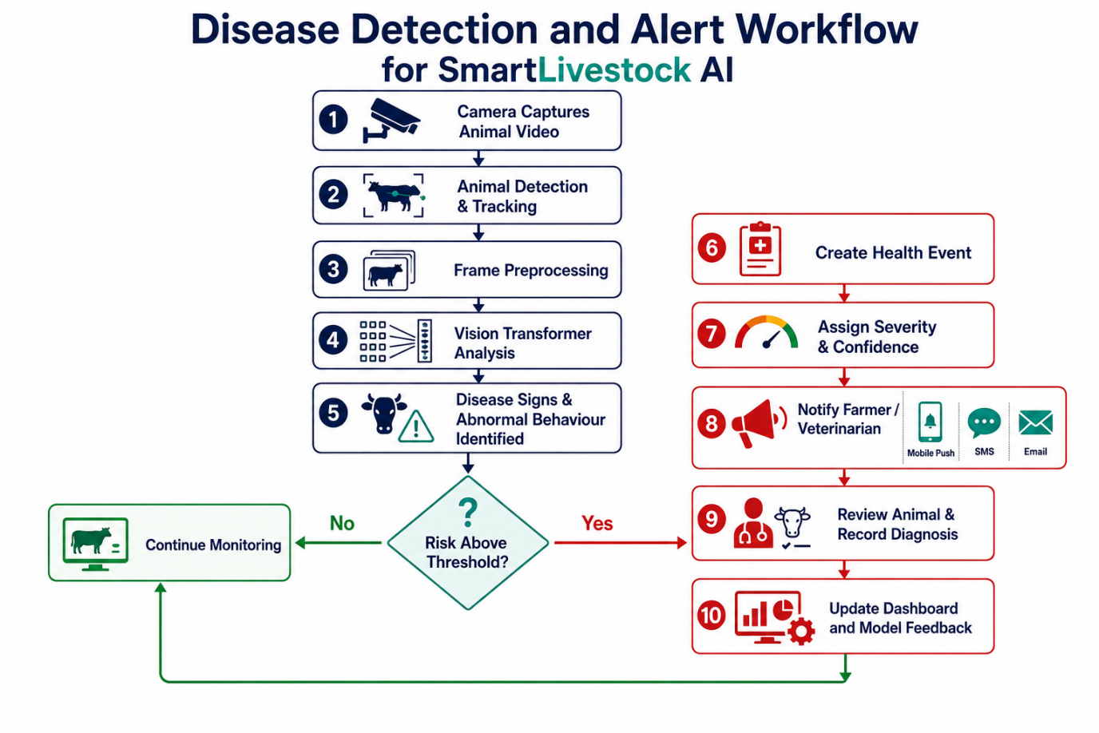
FIG 4.2: Disease Detection and Alert Workflow

4.5 Data Analysis & Engineering Judgment
Development required engineering judgment concerning dataset balance, model architecture selection, threshold calibration, and deployment latency. A pretrained Vision Transformer backbone was selected and fine-tuned rather than trained from scratch, given the relatively limited size of the annotated livestock dataset available for an academic project; transfer learning improved convergence and reduced the risk of overfitting.
Confidence and severity thresholds were tuned to balance false negatives (missed disease cases, which are the more costly error in an animal-welfare context) against false positives (unnecessary alerts, which risk alert fatigue among staff). The chosen thresholds favour slightly higher sensitivity for high-severity symptom categories.
For behaviour analysis, the anomaly-detection component compares short-term behaviour distributions against a rolling baseline rather than a fixed global threshold, since normal behaviour patterns vary across individual animals, time of day, and herd composition. This design choice reduces false anomaly flags caused by expected variation.

4.6 Comparison with Existing Solutions & Achievement of Objectives
Objective | Evidence | Achievement
Curate and annotate dataset | Labelled image/video dataset for disease and behaviour classes prepared | Fully Achieved
Fine-tune Vision Transformer for disease detection | ViT model trained and evaluated with reported accuracy | Fully Achieved
Behaviour classification and anomaly detection | Temporal transformer implemented with reported accuracy | Fully Achieved
Model-serving pipeline within latency target | Benchmarked inference latency meets near-real-time target | Fully Achieved
Alert engine and dashboard | Real-time alerts and analytics dashboard implemented | Fully Achieved
Structured MLOps pipeline | Dataset versioning, training, evaluation and deployment pipeline defined and used | Fully Achieved
Security and access control | Authentication, RBAC and encrypted storage/transport applied | Fully Achieved
Deployability on farm hardware | Containerized deployment validated on target server configuration | Achieved / Evaluated
Table 4.4: Achievement of Objectives
Compared with manual inspection and sensor-only monitoring, SmartLivestock AI provides continuous, non-invasive, symptom-specific visual monitoring combined with behaviour analysis in a single platform, and retains visual evidence that supports veterinary review, an advantage that neither purely manual nor purely sensor-based approaches provide on their own.

4.7 Strengths & Limitations
Strengths
- Combines disease-symptom detection and behaviour analysis in a single non-invasive, camera-based platform.
- Uses transfer learning to achieve strong accuracy with a comparatively modest annotated dataset.
- Retains supporting visual evidence for each alert, aiding veterinary review and reducing false-alarm impact.
- Provides individual-animal and herd-level analytics through an accessible dashboard.
- Follows a structured MLOps pipeline supporting reproducible training and controlled deployment.
- Non-invasive design avoids the hardware burden of wearable sensors.
Limitations
- Detection quality depends on camera placement, lighting, and coverage of the monitored area.
- Rare disease categories with limited training examples may be detected less reliably.
- The system depends on adequate compute (GPU) resources for timely inference at scale.
- Behaviour baselines require an initial observation period before anomaly detection becomes fully reliable for a new animal.
- The project is an academic implementation and requires further field validation, larger real-farm datasets, and veterinary review before production deployment.
- External integrations such as automated treatment dispensing or herd-management systems are outside the current scope.

4.8 Project Planning, Roles & Budget
Student | Assigned Responsibility | Actual Contribution
S.Krishna Chaithanya  (192424287) | Module 1: Animal Disease Detection | Built the capture and annotation pipeline, fine-tuned the ViT backbone, ran evaluation experiments, and tuned classification thresholds.
G.GopiChand  (192424384) | Module 2: Animal Behaviour Analysis | Implemented the temporal transformer for behaviour classification and the per-animal anomaly-scoring logic.
Bhuvan Kumar .J | Module 3: Alert and Monitoring System | Built the alert engine, severity prioritisation, farmer/vet dashboard, and model-performance monitoring.
Table 4.5: Individual Contribution / Roles
The project uses freely available frameworks, open-source tooling, and free-tier/institutional GPU credits where possible. The major resources invested are student time, model-training effort, annotation effort, testing, and documentation. Future field deployment with additional cameras, dedicated GPU servers, or managed cloud infrastructure would introduce additional operating costs.

CHAPTER 5
CONCLUSION, FUTURE WORK AND REFLECTION

5.1 Conclusion
SmartLivestock AI: Automated Animal Disease Detection and Behaviour Analysis Using Vision Transformers demonstrates how modern computer-vision architectures can be applied to a practical animal-welfare and farm-productivity problem. The system integrates data acquisition and annotation, Vision-Transformer-based disease-symptom detection, temporal behaviour analysis, and an alerting/analytics dashboard into a single monitoring platform.
The application reduces dependence on periodic manual inspection by providing continuous, non-invasive, camera-based observation. Confidence and severity thresholds, together with retained visual evidence, help ensure that automated flags remain useful and reviewable rather than opaque or overconfident.
The MLOps component extends the project beyond model training. Dataset and model versioning provide reproducibility, a defined evaluation quality gate improves confidence before deployment, containerization provides a repeatable serving environment, and live monitoring supports early detection of performance drift.
Overall, the project provides a practical foundation for vision-based precision livestock monitoring. It supports earlier detection of health concerns, more consistent observation than manual inspection alone, and data-driven herd-management insight, while recognising that automated detections must remain subject to veterinary and human judgement.

5.2 Future Work
- Expand the annotated dataset across more farms, breeds, lighting conditions, and disease categories to improve generalisation.
- Incorporate multi-camera and multi-angle fusion for more reliable symptom and behaviour detection.
- Explore lightweight/distilled Vision Transformer variants for efficient on-device edge deployment.
- Integrate optional physiological sensor data (e.g., activity or temperature) to complement visual detections.
- Add explainability visualisations (e.g., attention-map overlays) so veterinarians can see which image regions drove a detection.
- Develop mobile applications for real-time alerts to farm staff and veterinarians in the field.
- Introduce active-learning workflows so uncertain or novel cases are prioritised for annotation and retraining.
- Add automated data-drift and model-performance dashboards for long-term production monitoring.
- Collaborate with veterinary experts to validate detections against clinical outcomes at scale.
- Extend the platform to additional species and to early detection of specific high-impact diseases.

5.3 Professional Learning & Individual Reflection
The project provided practical exposure to the complete machine-learning system lifecycle, from dataset curation and model architecture selection through training, evaluation, deployment, and monitoring. Working with Vision Transformers in an animal-welfare context also highlighted that model accuracy alone is not sufficient; responsible thresholding, evidence retention, and human review are equally important engineering considerations.
New Knowledge Acquired
- Learned how Vision Transformers process image patches with self-attention and how this differs from convolutional feature extraction.
- Gained practical experience fine-tuning pretrained transformer backbones on a domain-specific dataset.
- Learned how temporal/video transformers can model behaviour from sequences of frames.
- Understood how MLOps practices (versioning, evaluation gates, monitoring) support reliable model deployment.
- Learned the importance of confidence/severity thresholding and evidence retention in an animal-welfare application.
- Improved understanding of deployment, containerization, and live-performance monitoring for ML services.
Engineering & Professional Skills Developed
- Improved deep-learning model development, evaluation, and debugging skills.
- Developed dataset-curation, annotation-management, and data-quality skills.
- Improved understanding of API design and model-serving architecture.
- Learned to document technical decisions, trade-offs, risks, and assumptions clearly.
- Developed teamwork, project-planning, and technical-presentation skills.
- Improved awareness of AI ethics, animal welfare, and responsible automated decision support.
Individual Reflection
My individual contribution to the SmartLivestock AI: Automated Animal Disease Detection and Behaviour Analysis Using Vision Transformers project focused on designing and developing the computer vision–based animal behaviour analysis module.
I collected and studied livestock image and video datasets containing behaviours such as feeding, walking, resting, grazing, drinking, isolation, and abnormal inactivity. I performed data preprocessing activities such as frame extraction, image resizing, normalization, augmentation, and behaviour annotation to prepare the data for model training.
I contributed to the following tasks:
- Designed the overall computer vision workflow for livestock monitoring.
- Prepared and labelled animal image and video datasets.
- Implemented animal detection and tracking in video frames.
- Applied Vision Transformer and deep-learning models for behaviour classification.
- Identified behavioural indicators associated with illness, injury, stress, and discomfort.
- Developed logic to detect abnormal movement, prolonged inactivity, isolation, and changes in feeding behaviour.
- Evaluated the model using accuracy, precision, recall, F1-score, and confusion matrix.
- Designed the conceptual health and behaviour analytics dashboard.
- Implemented an alert mechanism for notifying farmers about abnormal animal behaviour.
- Tested the system under different lighting, camera-angle, background, and occlusion conditions.
- Prepared the system architecture, workflow diagrams, experimental results, and project documentation.
Through this contribution, I developed practical knowledge of computer vision, Vision Transformers, dataset preparation, model evaluation, animal tracking, behaviour recognition, and AI-based livestock monitoring. My work helped the project achieve continuous animal observation, early detection of abnormal behaviour, and improved livestock health management.

REFERENCES
[1] A. Dosovitskiy et al., "An Image is Worth 16x16 Words: Transformers for Image Recognition at Scale," International Conference on Learning Representations (ICLR), 2021.
[2] A. Vaswani et al., "Attention Is All You Need," Advances in Neural Information Processing Systems (NeurIPS), 2017.
[3] National Institute of Standards and Technology (NIST), The NIST Cybersecurity Framework (CSF) 2.0, Gaithersburg, MD, 2024.
[4] OWASP Foundation, OWASP Top 10: The Ten Most Critical Web Application Security Risks, 2021.
[5] International Organization for Standardization, ISO/IEC 27001:2022 - Information Security, Cybersecurity and Privacy Protection - Information Security Management Systems - Requirements, 2022.
[6] PyTorch Documentation, PyTorch: An Open-Source Deep Learning Framework, PyTorch Foundation.
[7] Hugging Face / timm Documentation, PyTorch Image Models (timm) Library Documentation.
[8] OpenCV Documentation, Open Source Computer Vision Library Reference.
[9] Docker Documentation, Containerization and Docker Platform Documentation.
[10] Git Documentation, Distributed Version Control and Branching Documentation.
[11] MLflow Documentation, Open-Source Platform for the Machine Learning Lifecycle.
[12] World Organisation for Animal Health (WOAH/OIE), Terrestrial Animal Health Code, General guidance on animal disease surveillance and welfare.
[13] Precision Livestock Farming literature reviews on computer-vision-based animal monitoring, behaviour recognition, and health surveillance (representative survey sources).

APPENDICES
Appendix A - Detailed Calculations
Detailed calculations for SmartLivestock AI include classification accuracy, precision, recall, F1-score, confusion-matrix derivation, severity-score computation, false-alarm-rate calculation, and inference-latency benchmarking. The summarised engineering results are presented in Chapter 4.
Appendix B - Engineering Drawings / Schematics
The system architecture and model-development/deployment pipeline are presented in Figures 3.1 and 3.2. Data entities include cameras, animals, sessions/clips, disease-detection records, behaviour-classification records, alerts, and model-version metadata.
Appendix C - Source Code / Code Repository Information
The complete source code is maintained in the project's version-control repository, organised by module (data pipeline, disease-detection model, behaviour-analysis model, serving API, dashboard) and including configuration, training scripts, evaluation notebooks, and deployment configuration. Sensitive credentials and raw farm footage are excluded from the repository.
Appendix D - Datasheets
Not directly applicable for the software/model implementation. Camera hardware specifications (resolution, frame rate, field of view) used for data collection are documented separately where relevant to reproducing the dataset conditions.
Appendix E - Experimental / Raw Data
The project uses an annotated sample dataset of livestock images/video clips covering healthy and symptomatic animals and the defined behaviour classes, split into training, validation, and test sets. Datasets used for development and testing contain no unnecessary personal or farm-identifying information.
Appendix F - Ethics / Institutional Approval
No separate institutional ethics approval was required for this academic software/ML project. The design emphasises non-invasive data collection, responsible presentation of model outputs as decision support, and human/veterinary review of all health-related recommendations.
Appendix G - Project Meeting / Progress Records
Project discussions, module allocation, dataset-annotation reviews, training-experiment tracking, and progress updates were conducted among team members throughout the project.
Appendix H - User / Industry Feedback
Formal industry/farm feedback was not collected during the academic implementation. The system was evaluated through model-level testing, pipeline verification, and review against the defined engineering requirements.
Appendix I - Publications / Patents / Competitions / Product Outcomes
None to date. SmartLivestock AI was developed as an academic capstone project.
Appendix J - Individual Contribution Evidence
Individual contributions are documented in the Individual Contribution Statement and Table 4.5, including module responsibilities, development activities, and testing responsibilities.
Appendix K - Suggested Model/MLOps Verification Checklist
- Dataset version and annotation guidelines are documented and reviewed.
- Training run completes successfully with logged metrics.
- Validation and test-set evaluation meet the defined quality-gate thresholds.
- Confusion matrix and per-class metrics are reviewed for imbalance issues.
- Confidence/severity thresholds are calibrated and documented.
- Container image for the serving pipeline builds successfully.
- Deployment configuration is validated and inference latency is benchmarked.
- Application/health checks pass after deployment.
- Logs and monitoring metrics (including prediction-distribution drift) are available.
- Rollback procedure to a previous model version is documented.

CAPSTONE PROJECT OUTCOME MAPPING SHEET
Outcome / Evidence | SO / Area | Location in This Report
Complex engineering problem formulation | SO1 | Ch. 1, Ch. 2
Engineering design under constraints | SO2 | Ch. 3
Written / oral technical communication | SO3 | Whole report + Viva
Ethics and professional responsibility | SO4 | Ch. 3 (3.7) and Ch. 5
Teamwork and leadership | SO5 | Ch. 4 (4.8)
Experimentation, analysis and engineering judgment | SO6 | Ch. 4 (4.3-4.6)
Independent acquisition of new knowledge | SO7 | Ch. 5 (5.3)
Standards and secure engineering | SO2 | Ch. 3 (3.2, 3.7)
Sustainability and societal / environmental impact | SO2 / SO4 | Ch. 3 (3.7)
Risk assessment and mitigation | SO2 / SO4 | Ch. 3 (3.8)
Security considerations | Relevant SO | Ch. 3 (3.2, 3.7-3.8)
Integrated / system-level engineering | SO1 / SO2 | Ch. 3 (3.5)
Project planning and management | SO5 | Ch. 4 (4.8)
Individual contribution | SO1-SO7 | Contribution Statement + Ch. 4 (4.8)

